City Name, Mayor
123 Street Address, City, State Zip Code
Phone: 111.111.1111 | Email: mayor@city.gov | Website: http://city.gov

Template for Government Ordinance, Resolution, or Law
to Authorize Use of Child & Youth Impact Assessments
NOTE: Please adapt this template language to meet your community’s circumstances and goals, including, for example:

- Inserting the relevant level of government (e.g., mayor, county board or city council, school board, state legislature); and
- Adding a deeper focus on racial equity impacts affecting youth; and
- Adding a deeper focus on other marginalized youth, such as low-income, LQBTQ+, rural, system-involved youth, and others.
For assistance, contact Kids Impact Initiative at info@kidsimpact.org.
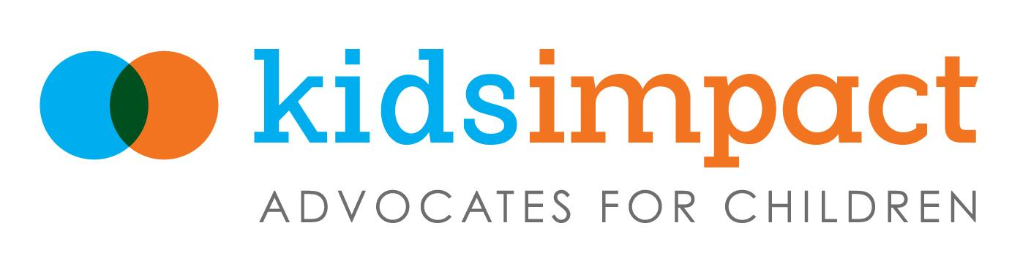

WHEREAS, child & youth impact assessments use structured questions to identify the expected and unintended consequences for youth of a proposed policy, budget, program, or practice; and

WHEREAS, children and youth are affected by nearly every policy and budget decision elected officials make, but impact assessments are rarely used; and

WHEREAS, child & youth impact assessments give decision-makers information to best meet the needs of their youngest constituents by providing a methodical way for them to understand and address proposals’ effects on young people; and

WHEREAS, too many children and youth in our community are not thriving in terms of their education, social and emotional well-being, and healthy development; and

WHEREAS, child & youth impact assessments can improve children’s opportunities to succeed by systematically elevating their needs when it comes to policy and budget decisions; and

WHEREAS, child & youth impact assessments help policymakers address racial and other inequities facing young people; and

WHEREAS, child & youth impact assessments provide an avenue for youth to have a meaningful voice in shaping policies that affect them; and

WHEREAS, child & youth impact assessments are especially valuable to policymakers for proposals they may not think affect youth but, in fact, affect their lives every day—like those related to transportation, housing, parks, broadband, the environment, among others;

NOW, THEREFORE BE IT RESOLVED that child & youth impact assessments shall be conducted on policy, budget, or other proposals submitted to (insert government entity) for consideration by members of that body, with sufficient time for careful review and action by decision-makers before a final decision on the proposal is made.

IMPORTANT IMPLEMENTATION DETAILS TO CONSIDER INCLUDING:

BE IT FURTHER RESOLVED
- That the chief executive’s office will report back to (insert relevant body of elected officials) within four months of enactment of this resolution on how child & youth impact assessments will be implemented, including questions to be answered, incorporating input from relevant community leaders, including youth;
- That the analysis for child & youth impact assessments be conducted by (insert relevant office, such as office of research or office related to children’s well-being, etc.);
- That the assessment questions be tied to the (insert relevant level of government)’s existing agenda, goals, or bill of rights for children;

- That the findings and recommendations in the child & youth impact assessments be made available to the public with sufficient time to share with decision-makers before they make a final decision on the proposal;

- That needed funds be allocated each year for costs associated with implementing child & youth impact assessments—including staff to coordinate with relevant divisions in government and to produce and disseminate the analyses, along with training to use the assessment tool. (Note: these functions may fall within the charge of existing research entities in government and not require new funds);

- That the first year of implementing child & youth impact assessments be monitored by the chief executive’s office in (insert relevant government entity) with course corrections made as needed for maximum efficiency and effectiveness and that in subsequent years outcomes from using impact assessments be tracked and reported to policymakers for continuous improvement; and

- That this requirement be carried out for a minimum of five years at which time it will be reviewed and adapted by (insert government entity), based on recommendations from the chief executive, to achieve maximum value.

APPROVED, this ___ day of _____________, _____:

______________________________________________
Name, Mayor

______________________________________________
Name, City Council Member

______________________________________________
Name, City Council Member

